

**Iceland**

**Iceland’s volcanoes:** Iceland was formed from volcanic activity about 16 million years ago. Today Iceland is covered with more than 100 volcanoes. Most of these are now **extinct** (which measn they no longer erupt) but about 30 are thought to be **active**. Iceland’s most active volcanoes are called **Grimsvotn** and **Hekla**.

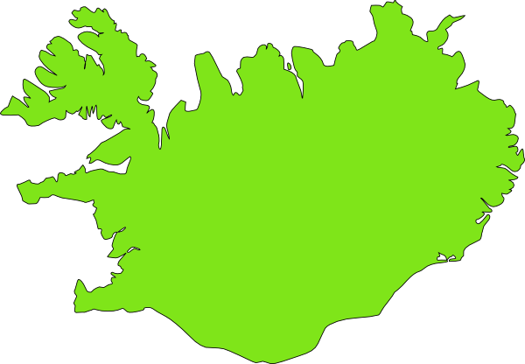

**Eyjafjallajökull**

**Hekla**

**Krafla**

**Grímsvötn**

**Katla**

**Bardabunga**

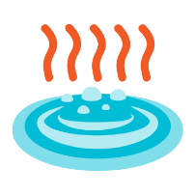



**= volcano**

**Geothermal Energy:** The **magma** (molten rock) underneath Iceland gives off a lot of **heat**. This warms the surface water and creates **natural hot springs** like the Blue Lagoon as well as jets of hot water and steam, called **geysers**. Heat from the Earth is called **geothermal energy** and it can be used to heat homes and to generate electricity. In Iceland 85% of heating and 25% of electricity is currently generated by geothermal energy.

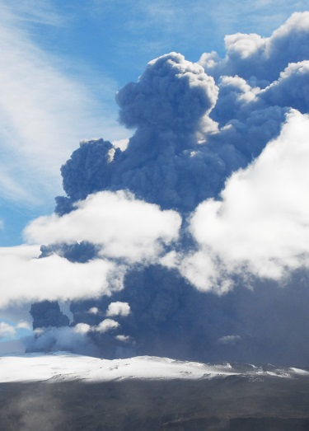

**Ice and ash:** Most of Iceland’s volcanoes are covered by **ice caps** and **glaciers**. In 2010, a volcano called **Eyjafjallajokull** (ey-ya-fyat-lah-yo-kull) erupted, and part of the ice cap on top of the volcano melted. This caused large **glacial floods** (known as jökulhlaups) and huge **ash clouds** were ejected into the sky. Because ash particles can damage aeroplane engines, the eruption caused disruptions to air travel in Europe for a whole month.



**The Himalayas**

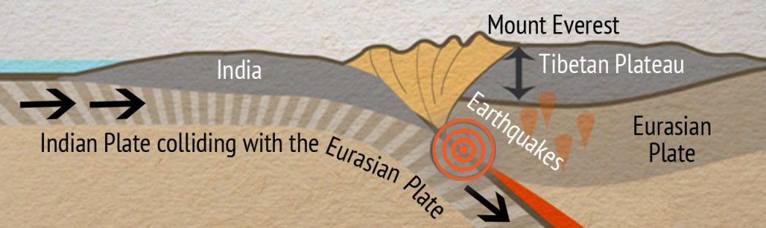

**Tethys Ocean:** Millions of years ago, before the **Indian plate** collided with the **Eurasian Plate** to create the **Himalayas**, there was an ancient ocean called the **Tethys Ocean** between India and Asia. We know this because parts of the Himalayan Mountains, including the uppermost part of Mount Everest, are made from rocks called **limestone**. These limestone rocks contain **fossils** of ancient sea creatures that would have lived in shallow tropical seas in the **Ordovician period**, 470 million years ago. As the Indian Plate has moved towards the Eurasian plate over the past 50 million years, these limestones have been pushed up from the sea floor to form the Himalayas.

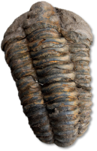

**Natural Disasters:** Earthquakes are common natural disasters in the Himalayas. A particularly severe earthquake of **magnitude 7.8** occurred near **Kathmandu** in **Nepal** in April 2015. This earthquake killed nearly 9000 people and injured thousands more across Nepal, China, India and Bangladesh. 600,000 building structures were either damaged or completely destroyed and 2.8 million people were left homeless after the quake.

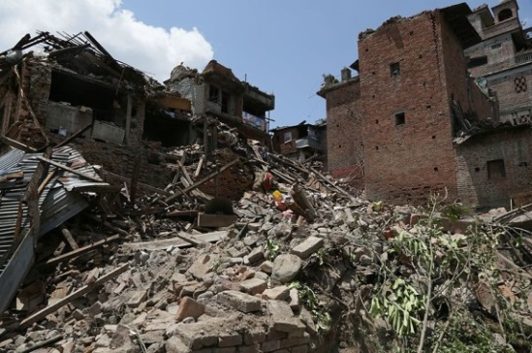

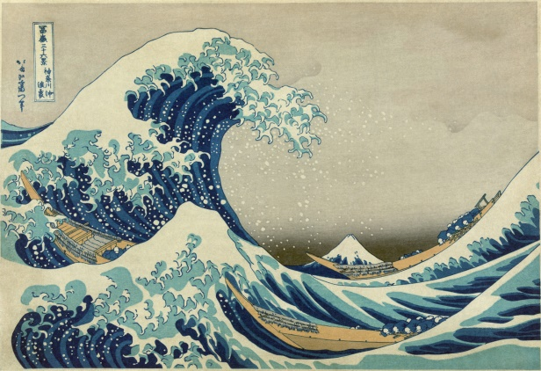****

**Japan**

**Tsunami:** If the sea floor moves abruptly in an **earthquake** it can cause the water above to rise into a huge wave called a **tsunami** (pronounced ‘su-nami’). Tsunamis spread out fast across the ocean and as they get closer to land the waves increase in height. In the **2011 Tohoku earthquake** in Japan, tsunami waves reached a massive height of 40m, that’s as tall as a 12-storey building! When tsunamis crash on land they can be catastrophic, completely wiping out whole towns.

**Pacific Ring of Fire:** Japan is located on the ‘Pacific Ring of Fire’. This is the region surrounding the Pacific plate where most **earthquakes** and **volcanoes** occur on Earth. Over 75% of volcanoes and earthquakes occur on the Ring of Fire.

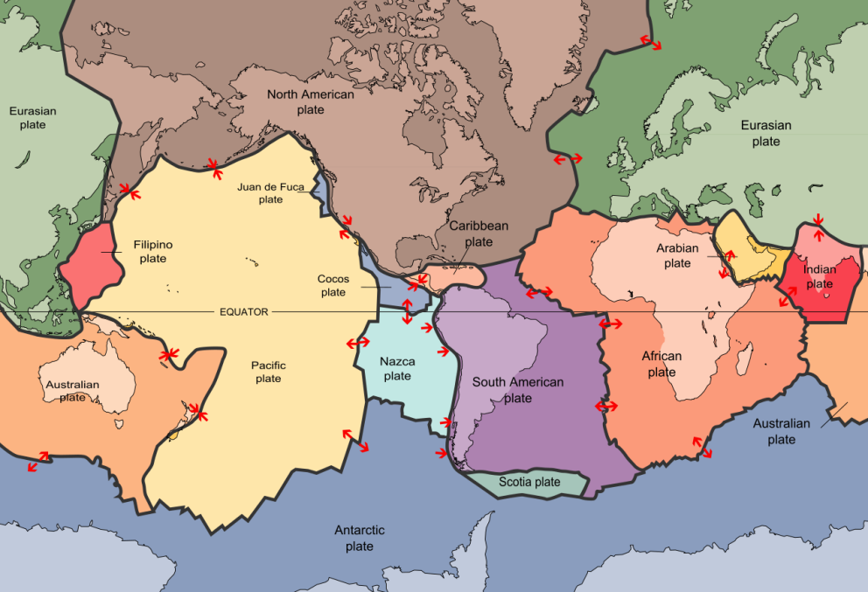



**San Andreas fault**

**How are earthquakes detected?** The strength of an earthquake is called its **magnitude.** Geologists can measure the magnitude of an earthquake by using an instrument called a **seismometer** which measures the **seismic energy** released by the earthquake. The more seismic energy released, the more the Earth shakes and the greater the earthquake’s magnitude. Earthquakes with a magnitude less than 5 don’t usually cause much damage but earthquakes above magnitude 6 can cause a lot of damage to both buildings and people.

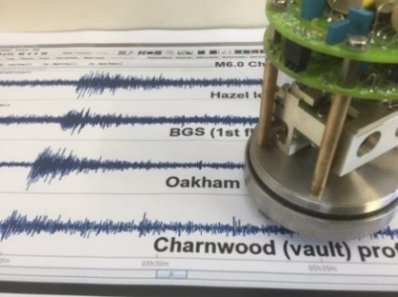

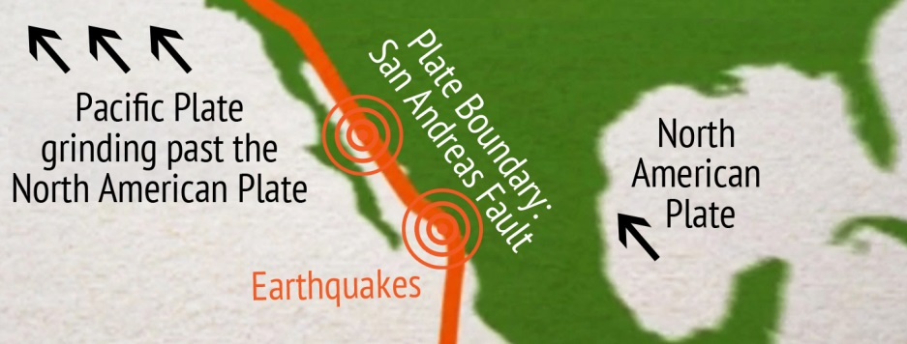

**What will happen in the future?** The **Pacific** and **North American Plates** are both moving in a **North West** direction, however the Pacific Plate is moving much faster than the North American Plate. If current rates of movement stay the same in the future, the city of Los Angeles (currently 550km south of San Francisco) will be level with San Francisco in around 20 million years.

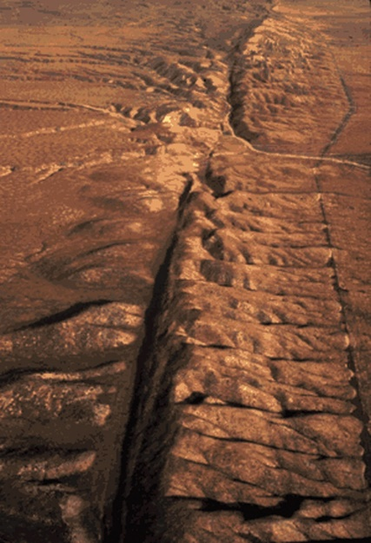



**Hawaiian Islands**

**Shield volcanoes:** The Hawaiian chain volcanoes are all a type of volcano called a **shield volcano**. Shield volcanoes form from **gentle eruptions** (effusive) of **runny lava** called **basalt**. Because it’s so runny, this lava can travel far before it solidifies into rock and creates wide, sloping volcanoes in the shape of a shield. The island of Hawaii, ‘Big Island’, is made from five major shield volcanoes: Kilauea, Mauna Loa, Mauna Kea, Kohala and Hualalai.

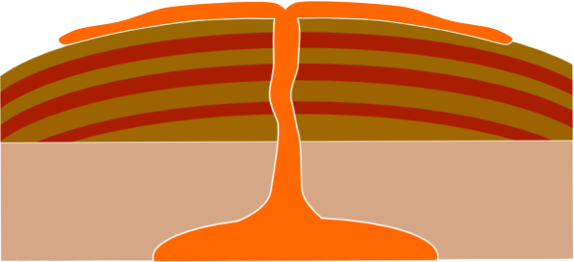

**Runny lava**

**Gentle slope**

**Stratovolcanoes:** The other main type of volcano that we find on Earth is a stratovolcano. These usually form at **destructive boundaries** when one plate is being forced under another plate like in Japan, or in the Andes. Stratovolcanoes look different to shield volcanoes because they are **cone-shaped** and have **steep sides**. This is because the lava that erupts from stratovolcanoes,called **andesite** lava, is much thicker than **basalt** lava and so cannot spread out very far after it has erupted.

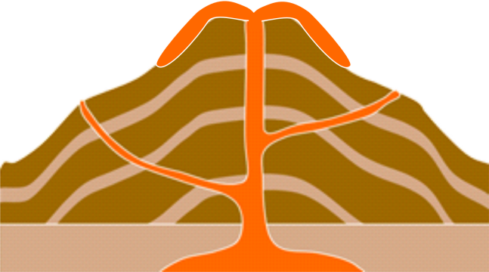****

**Thick lava**

**Steep slope**